EXPERIMENT 4
RAILWAY RESERVATION SYSTEM
AIM:
To develop an efficient Railway Reservation System that allows users to book, manage, cancel, and track train tickets online, while enabling administrators to manage trains, seats, fares, payments, and reservations.
CODE:
<!DOCTYPE html>
<html>
<head>
<title>Railway Reservation System</title>
<style>
body{font-family:Arial;background:#f2f2f2;margin:0}
header{background:#174a7c;color:white;padding:20px;text-align:center}
.container{width:90%;max-width:700px;margin:30px auto}
.card{background:white;padding:20px;margin:15px 0;border-radius:8px}
input,select,button{padding:10px;margin:6px;width:90%}
button{background:#174a7c;color:white;border:0;cursor:pointer}
.train{border:1px solid #ddd;padding:15px;margin:10px 0}
</style>
</head>
<body>
<header>
<h1>🚆 Railway Reservation System</h1>
</header>
<div class="container">
<!-- Login -->
<div class="card" id="login">
<h2>Passenger Login</h2>
<input id="user" placeholder="Username">
<input id="pass" type="password" placeholder="Password">
<button onclick="login()">Login</button>
</div>
<!-- Reservation -->
<div class="card" id="system" style="display:none">
<h2>Search Train</h2>
<input id="from" placeholder="From Station">
<input id="to" placeholder="To Station">
<input id="date" type="date">
<select id="class">
<option>Sleeper</option>
<option>AC 3 Tier</option>
<option>AC 2 Tier</option>
<option>First AC</option>
</select>
<button onclick="search()">Search Train</button>
<div id="result"></div>
<h2>PNR Status</h2>
<input id="pnr" placeholder="Enter PNR">
<button onclick="checkPNR()">Check PNR</button>
<p id="status"></p>
</div>
</div>
<script>
let PNR="";
function login(){
if(user.value=="passenger" && pass.value=="1234"){
login.style.display="none";
system.style.display="block";
}else{
alert("Invalid Login");
}
}
function search(){
if(!from.value || !to.value || !date.value){
alert("Enter all details");
return;
}
result.innerHTML=`
<div class="train">
<h3>Chennai Express</h3>
<p>${from.value} → ${to.value}</p>
<p>Available Seats: 25</p>
<p>Fare: ₹550</p>
<button onclick="book()">Book Ticket</button>
</div>`;
}
function book(){
PNR=Math.floor(1000000000+Math.random()*9000000000);
alert("Ticket Booked Successfully!\nPNR: "+PNR);
}
function checkPNR(){
if(pnr.value==PNR)
status.innerHTML="✅ Ticket Confirmed";
else
status.innerHTML="❌ PNR Not Found";
}
</script>
</body>
</html>
OUTPUT:
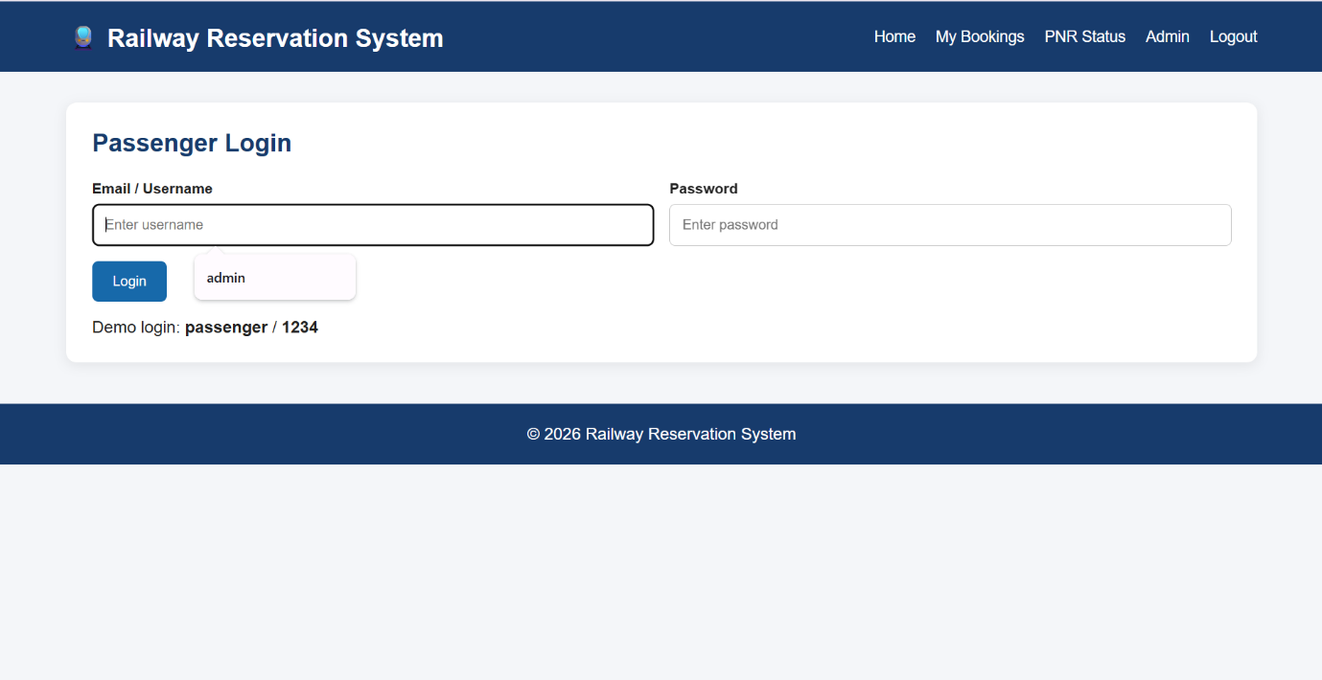

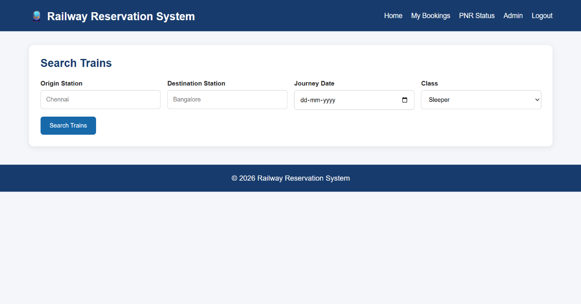

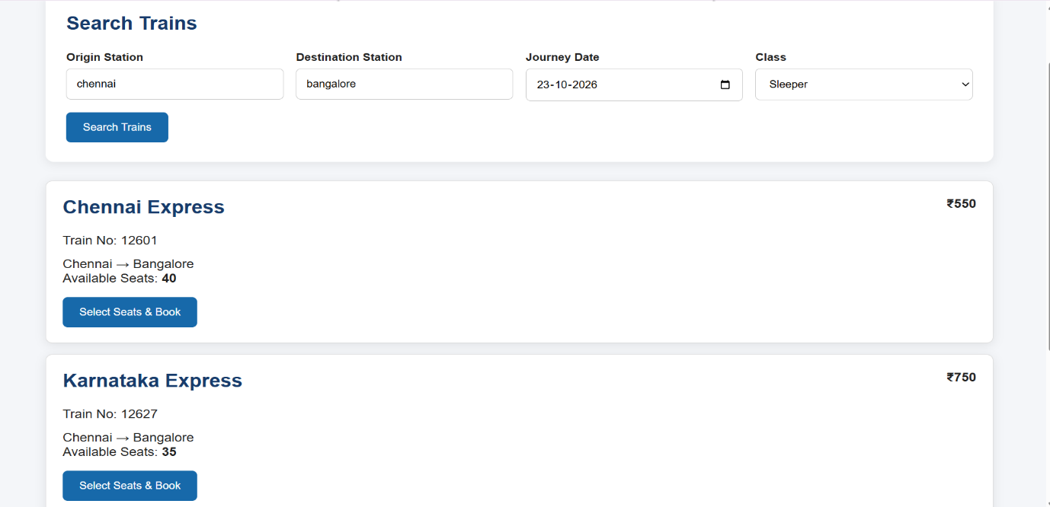
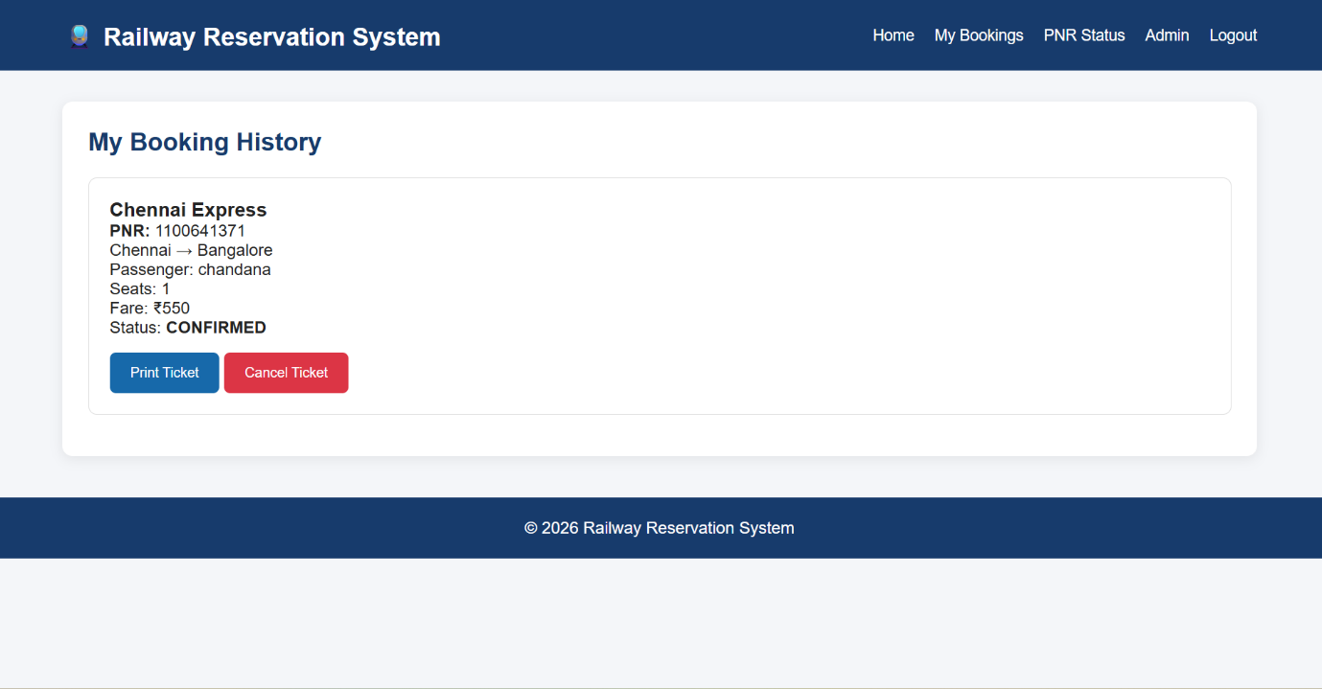
RESULT:
The Railway Reservation System allows the passenger to log in, search trains, check seat availability, book a ticket, generate a PNR number, and check the PNR status successfully.

